External Tangency

Definition
# Source: AI Source: Provided by: [Data Path: Persons Table -> ID Column: 1, Name_En Column: Motasem Essam] -> From: [ChatGPT] on [7/25/2026]
External Tangency occurs when two circles touch each other at exactly one point from the outside.
The circles are separate except for their single common point, called the point of tangency.
If the circles are $C_{1}$ and $C_{2}$:
$$\boxed{C_{1}∩C_{2}=\{P\}}$$
where (P) is the point of tangency.
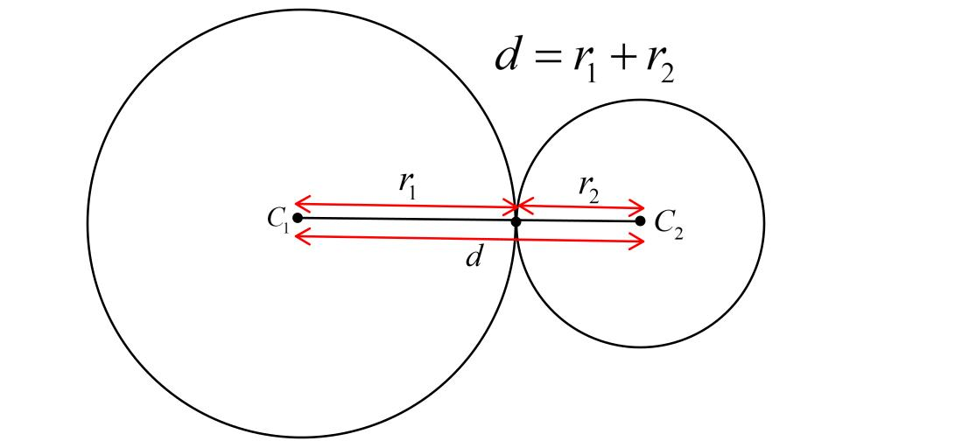
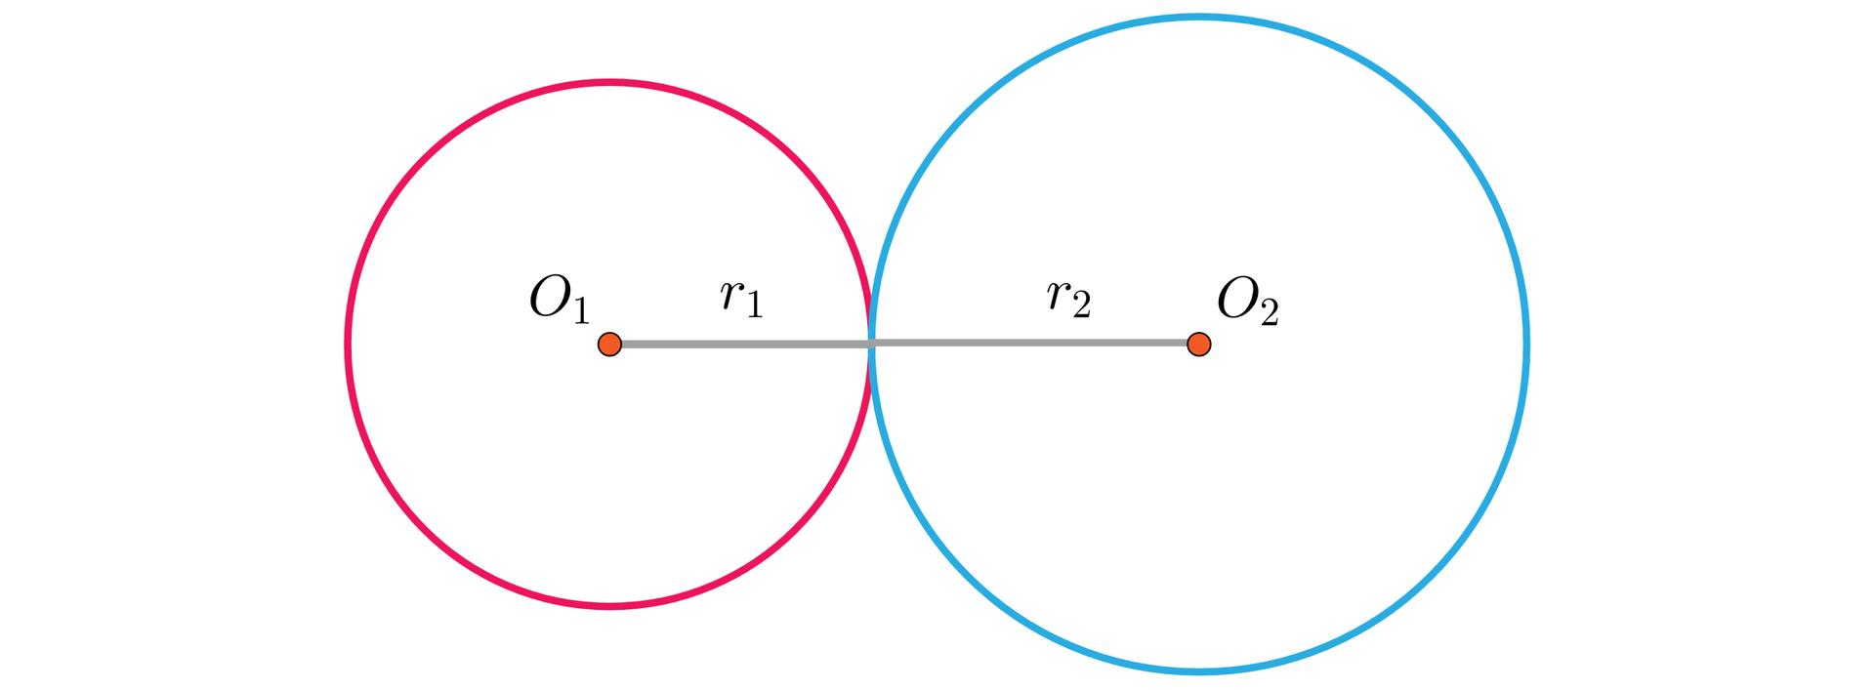
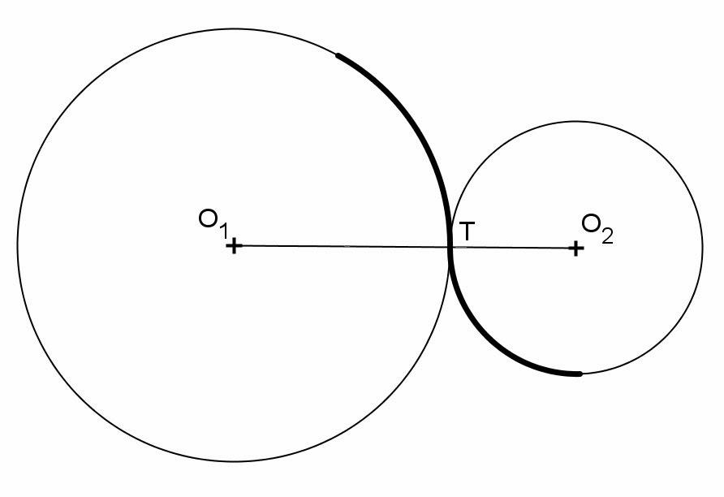

Purpose
# Source: AI Source: Provided by: [Data Path: Persons Table -> ID Column: 1, Name_En Column: Motasem Essam] -> From: [ChatGPT] on [7/25/2026]
External tangency is used to:
- Determine when two circles touch externally.
- Calculate the distance between circle centers.
- Analyze circular objects that are in contact.
- Study relationships between circles.
- Solve geometry problems.
- Design gears and wheels.
- Model mechanical components.
- Create tangent constructions in CAD.
- Analyze circular paths and structures.

Fundamental Idea
# Source: AI Source: Provided by: [Data Path: Persons Table -> ID Column: 1, Name_En Column: Motasem Essam] -> From: [ChatGPT] on [7/25/2026]
For two externally tangent circles:
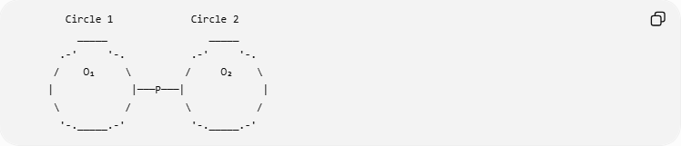
Circle 1 Circle 2
_____ _____
.-' '-. .-' '-.
/ O₁ \ / O₂ \
| |───P───| |
\ / \ /
'-._____.-' '-._____.-'
The circles touch at exactly one point:
$$\boxed{P}$$
The centers and the point of tangency lie on the same straight line:
$$\boxed{O_{1}-P-O_{2}}$$

Mathematical Condition
# Source: AI Source: Provided by: [Data Path: Persons Table -> ID Column: 1, Name_En Column: Motasem Essam] -> From: [ChatGPT] on [7/25/2026]
Let:
- $r_{1}$ = radius of the first circle.
- $r_{2}$ = radius of the second circle.
- $d$ = distance between their centers.
For external tangency:
$$\boxed{d=r_{1}+r_{2}}$$
This is the fundamental condition for external tangency.
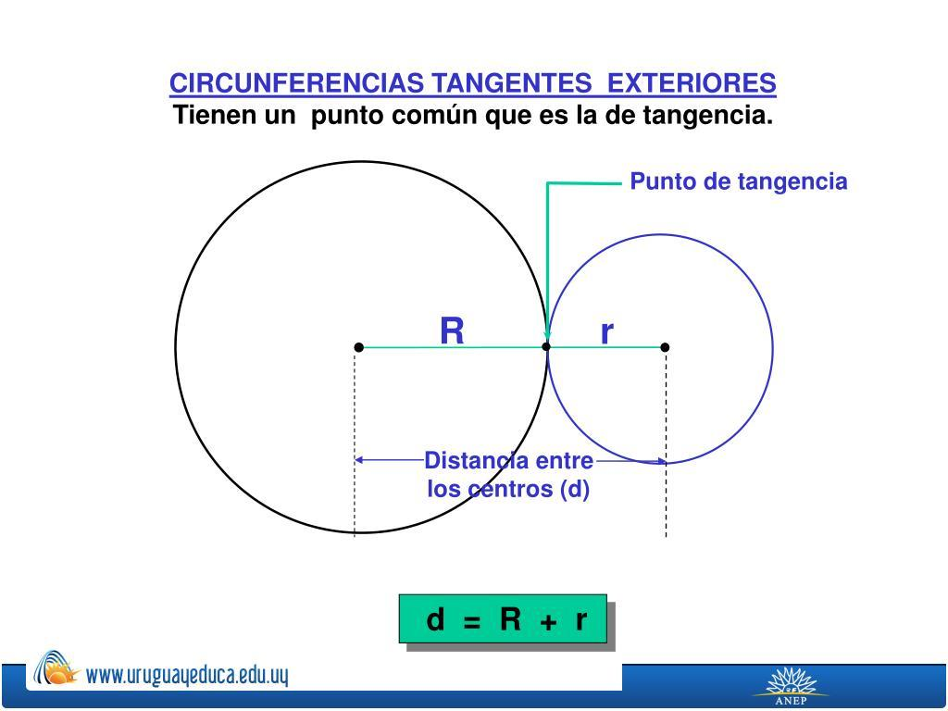

Why Is the Distance the Sum of the Radii?
# Source: AI Source: Provided by: [Data Path: Persons Table -> ID Column: 1, Name_En Column: Motasem Essam] -> From: [ChatGPT] on [7/25/2026]
The distance from the first center to the tangency point is:
$$O_{1}P=r_{1}$$
The distance from the second center to the tangency point is:
$$PO_{2}=r_{2}$$
Since the centers are on opposite sides of $P$:
$$O_{1}O_{2}=O_{1}P+PO_{2}$$
Therefore:
$$\boxed{d=r_{1}+r_{2}}$$

Point of Tangency
# Source: AI Source: Provided by: [Data Path: Persons Table -> ID Column: 1, Name_En Column: Motasem Essam] -> From: [ChatGPT] on [7/25/2026]
The point where the two circles touch is called the:
$$\boxed{\text{Point of Tangency}}$$
or:
$$\boxed{\text{Point of Contact}}$$
At this point:
$$\boxed{P∈C_{1}}$$
and:
$$\boxed{P∈C_{2}}$$
Therefore:
$$\boxed{P∈C_{1}∩C_{2}}$$
But there is no other common point.

Number of Common Points
# Source: AI Source: Provided by: [Data Path: Persons Table -> ID Column: 1, Name_En Column: Motasem Essam] -> From: [ChatGPT] on [7/25/2026]
Externally tangent circles have exactly:
$$\boxed{1}$$
common point.
Therefore:
$$\boxed{\left|C_{1}∩C_{2}\right|=1}$$
This distinguishes external tangency from other circle relationships.

Example 1 — Equal Radii
# Source: AI Source: Provided by: [Data Path: Persons Table -> ID Column: 1, Name_En Column: Motasem Essam] -> From: [ChatGPT] on [7/25/2026]
Suppose two circles each have radius:
$$r_{1}=5 \\ r_{2}=5$$
For external tangency:
$$d=r_{1}+r_{2}$$
Therefore:
$$d=5+5 \\ \boxed{d=10}$$
The centers must be $10$ units apart.
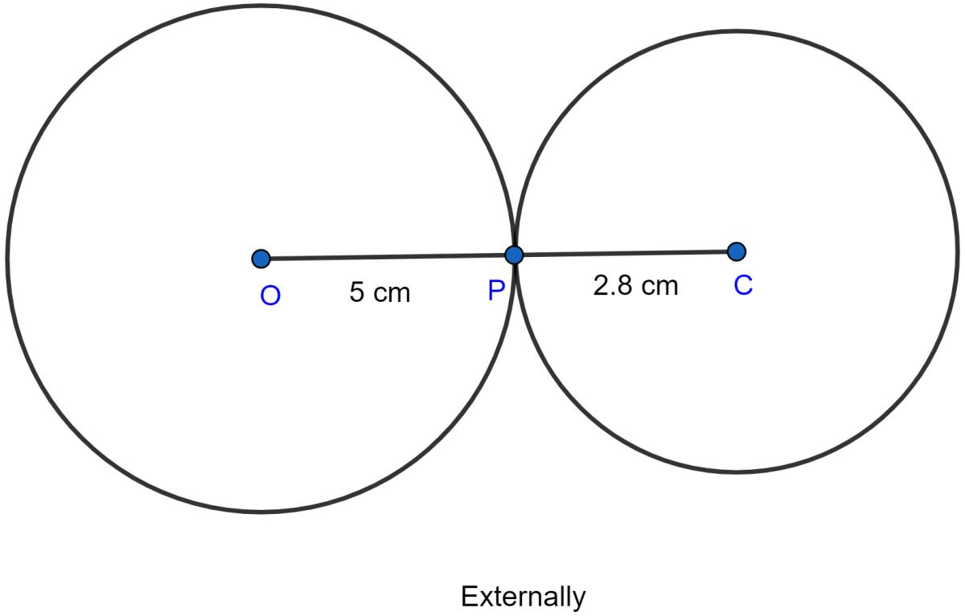
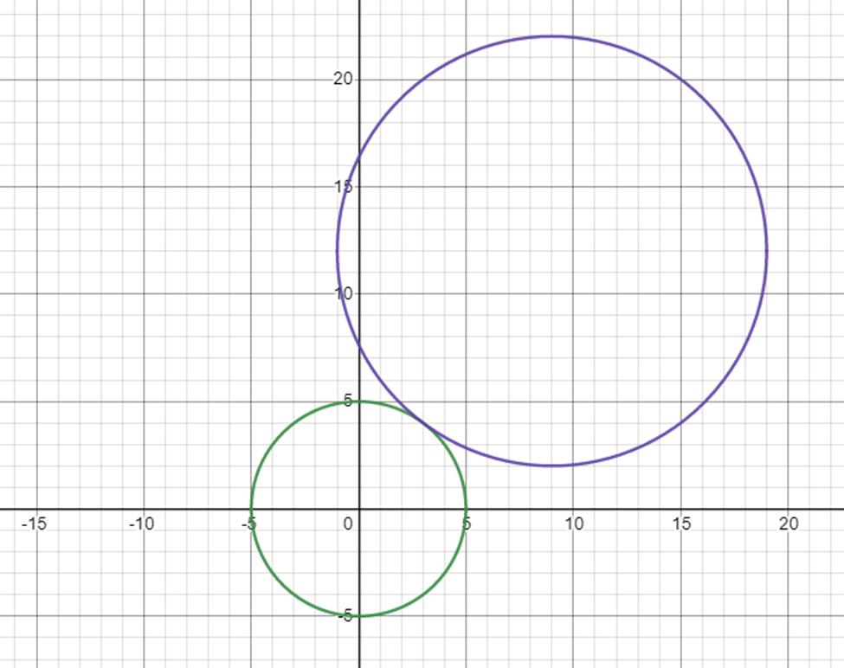
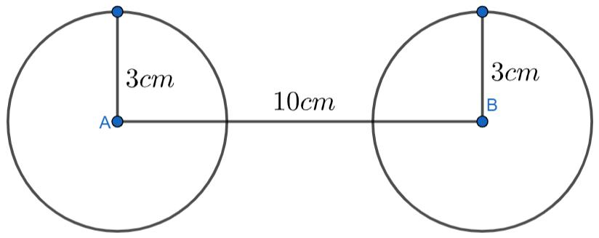

Example 2 — Different Radii
# Source: AI Source: Provided by: [Data Path: Persons Table -> ID Column: 1, Name_En Column: Motasem Essam] -> From: [ChatGPT] on [7/25/2026]
Suppose:
$$r_{1}=3$$
and:
$$r_{2}=7$$
For external tangency:
$$d=r_{1}+r_{2}$$
Therefore:
$$d=3+7 \\ \boxed{d=10}$$
The centers must be $10$ units apart.

Example 3 — Determining Whether Two Circles Are Externally Tangent
# Source: AI Source: Provided by: [Data Path: Persons Table -> ID Column: 1, Name_En Column: Motasem Essam] -> From: [ChatGPT] on [7/25/2026]
Suppose:
$$r_{1}=4 \\ r_{2}=6$$
and the distance between centers is:
$$d=10$$
Calculate:
$$r_{1}+r_{2}=4+6=10$$
Since:
$$d=r_{1}+r_{2}$$
the circles are externally tangent.
$$\boxed{\text{External Tangency}}$$

Example 4 — Not Externally Tangent
# Source: AI Source: Provided by: [Data Path: Persons Table -> ID Column: 1, Name_En Column: Motasem Essam] -> From: [ChatGPT] on [7/25/2026]
Suppose:
r_1=4
r_2=6
but:
$$d=12$$
For external tangency, we need:
$$d=4+6=10$$
But:
$$12≠10$$
Therefore:
$$\boxed{\text{The circles are not externally tangent}}$$
Since:
$$d>r_{1}+r_{2}$$
the circles are separated and have no intersection.

External Tangency vs. Two-Point Intersection
# Source: AI Source: Provided by: [Data Path: Persons Table -> ID Column: 1, Name_En Column: Motasem Essam] -> From: [ChatGPT] on [7/25/2026]
Consider two circles.
External Tangency
$$d=r_{1}+r_{2}$$
They touch at exactly one point.
Two-Point Intersection
$$\left|r_{1}-r_{2}\right|<d<r_{1}+r_{2}$$
They intersect at two points.
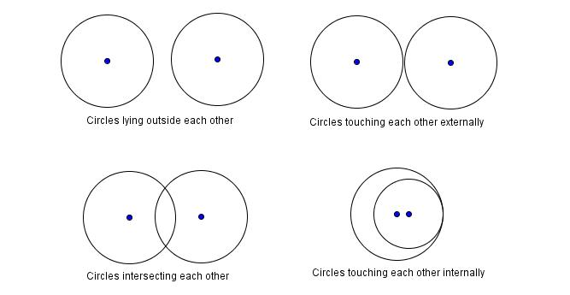
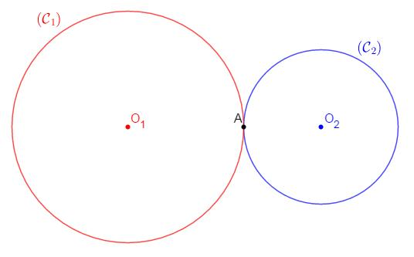
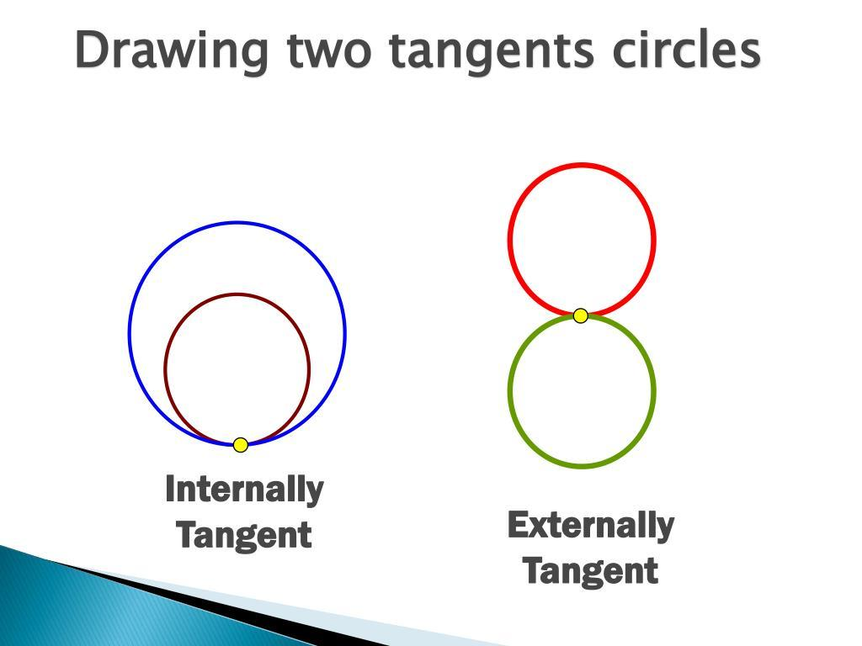
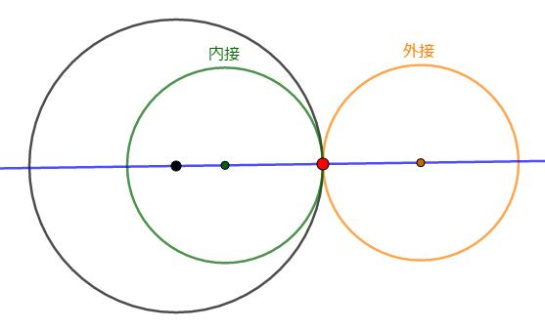

External Tangency vs. No Intersection
# Source: AI Source: Provided by: [Data Path: Persons Table -> ID Column: 1, Name_En Column: Motasem Essam] -> From: [ChatGPT] on [7/25/2026]
If:
$$d>r_{1}+r_{2}$$
the circles are separated:
$$\boxed{C_{1}∩C_{2}=∅}$$
If:
$$d=r_{1}+r_{2}$$
the circles are externally tangent:
$$\boxed{C_{1}∩C_{2}=\{P\}}$$
Therefore:
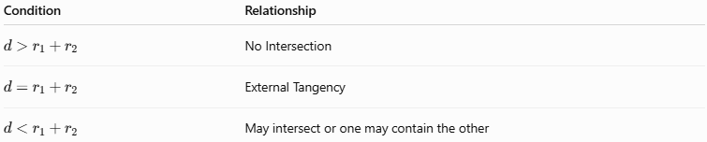
Condition | Relationship
$$d>r_{1}+r_{2}$$ | No Intersection
$$d=r_{1}+r_{2}$$ | External Tangency
$$d<r_{1}+r_{2}$$ | May intersect or one may contain the other

External Tangency vs. Internal Tangency
# Source: AI Source: Provided by: [Data Path: Persons Table -> ID Column: 1, Name_En Column: Motasem Essam] -> From: [ChatGPT] on [7/25/2026]
These two relationships are important to distinguish.
External Tangency
The circles touch from the outside:
$$\boxed{d=r_{1}+r_{2}}$$
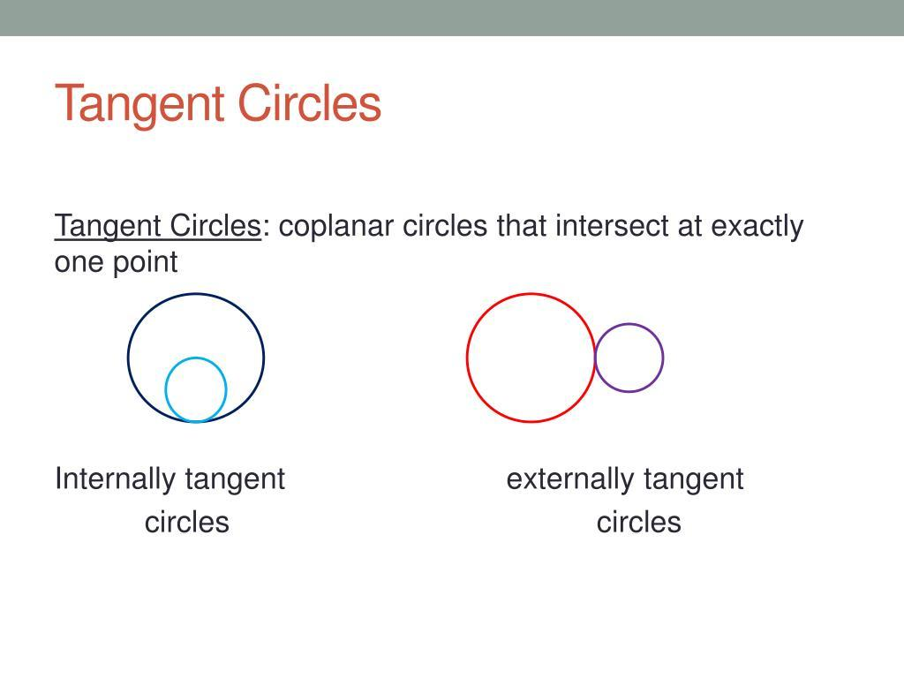
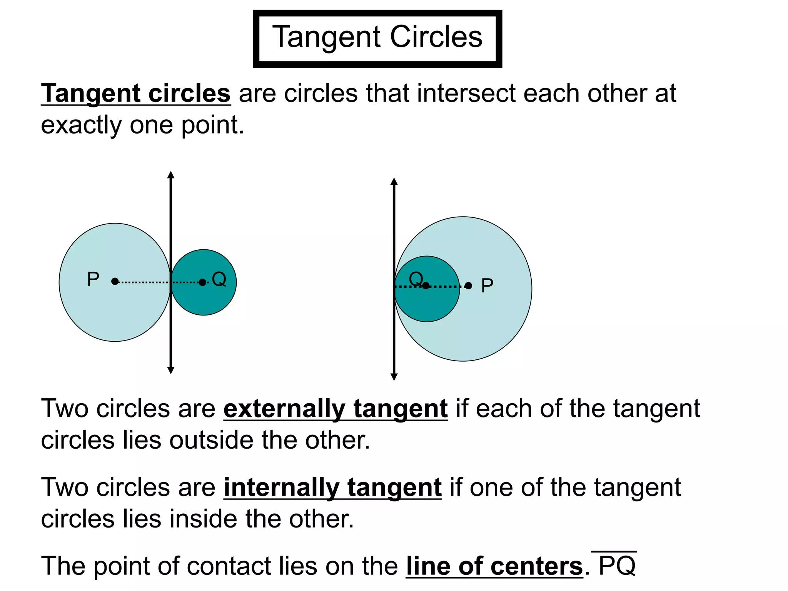
Internal Tangency
One circle is inside the other and they touch internally:
$$\boxed{d=\left|r_{1}-r_{2}\right|}$$

Centers and Point of Tangency
# Source: AI Source: Provided by: [Data Path: Persons Table -> ID Column: 1, Name_En Column: Motasem Essam] -> From: [ChatGPT] on [7/25/2026]
For externally tangent circles, the two centers and the point of tangency are collinear.
$$\boxed{O_{1},P,O_{2}}$$
lie on the same straight line.
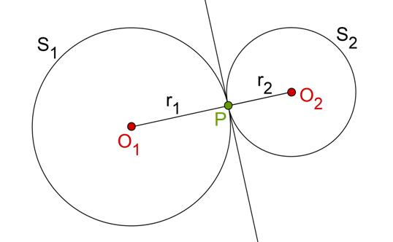
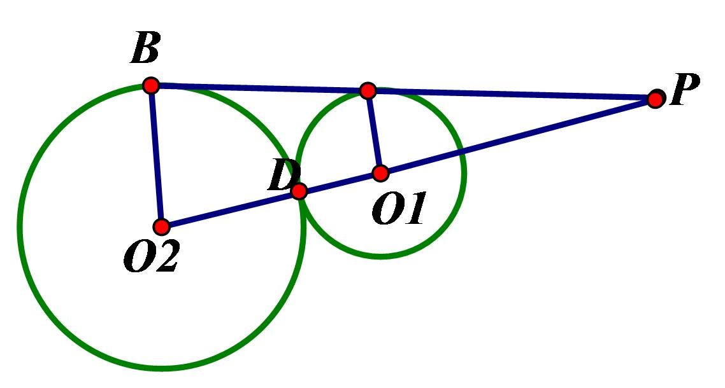
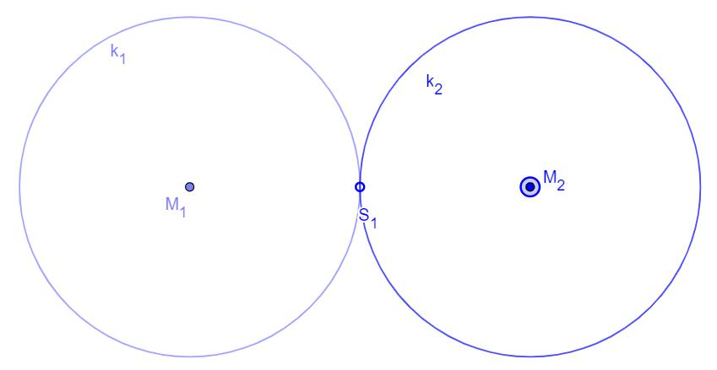
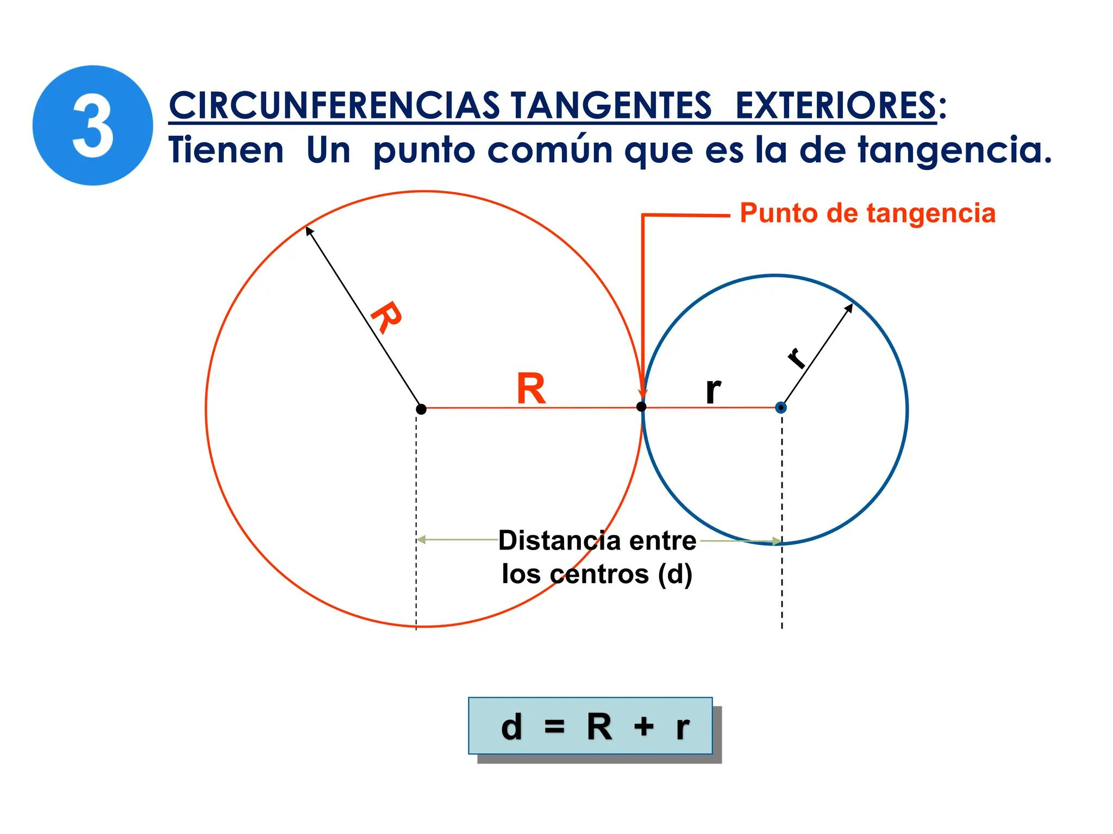
This gives:
$$\boxed{O_{1}P=r_{1}}$$
and:
$$\boxed{PO_{2}=r_{2}}$$
Therefore:
$$\boxed{O_{1}O_{2}=r_{1}+r_{2}}$$

Common Tangent at the Point of Contact
# Source: AI Source: Provided by: [Data Path: Persons Table -> ID Column: 1, Name_En Column: Motasem Essam] -> From: [ChatGPT] on [7/25/2026]
At the point of external tangency $P$, there is a common tangent line to both circles.
The tangent line is perpendicular to the line connecting the centers:
$$\boxed{l⊥O_{1}O_{2}}$$
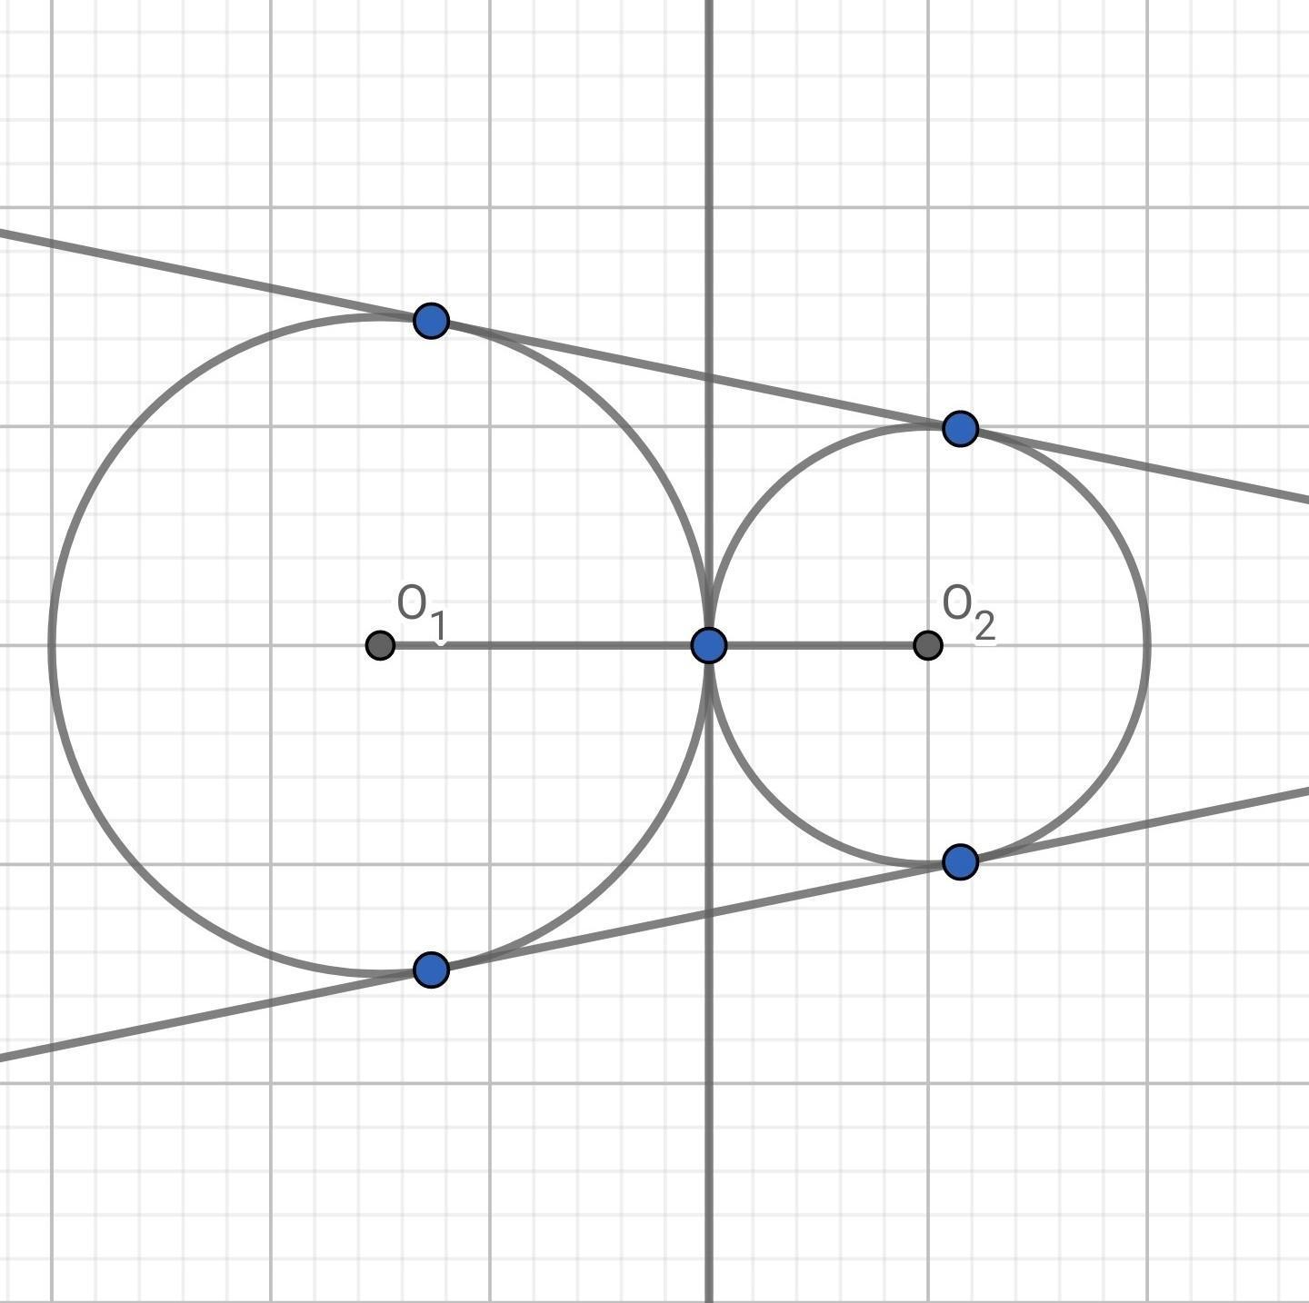
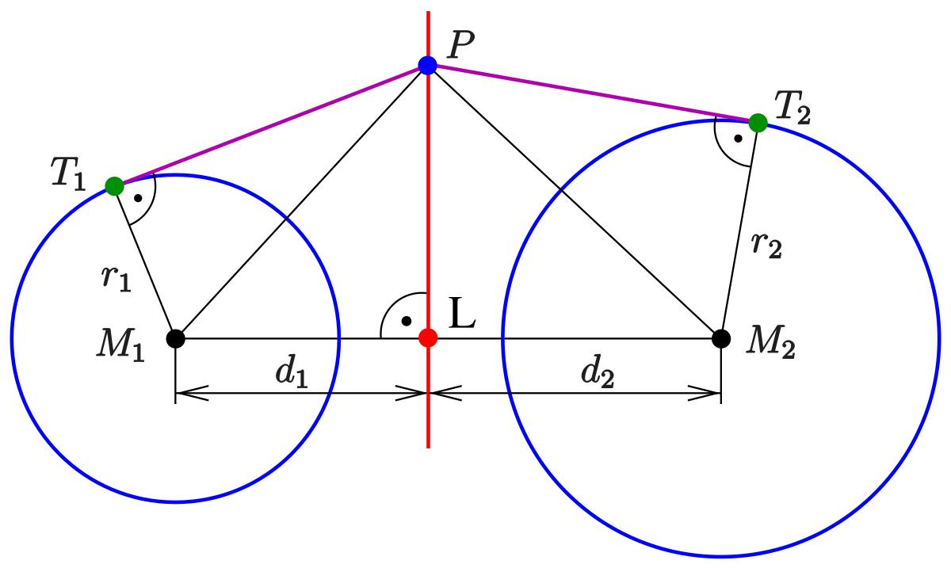
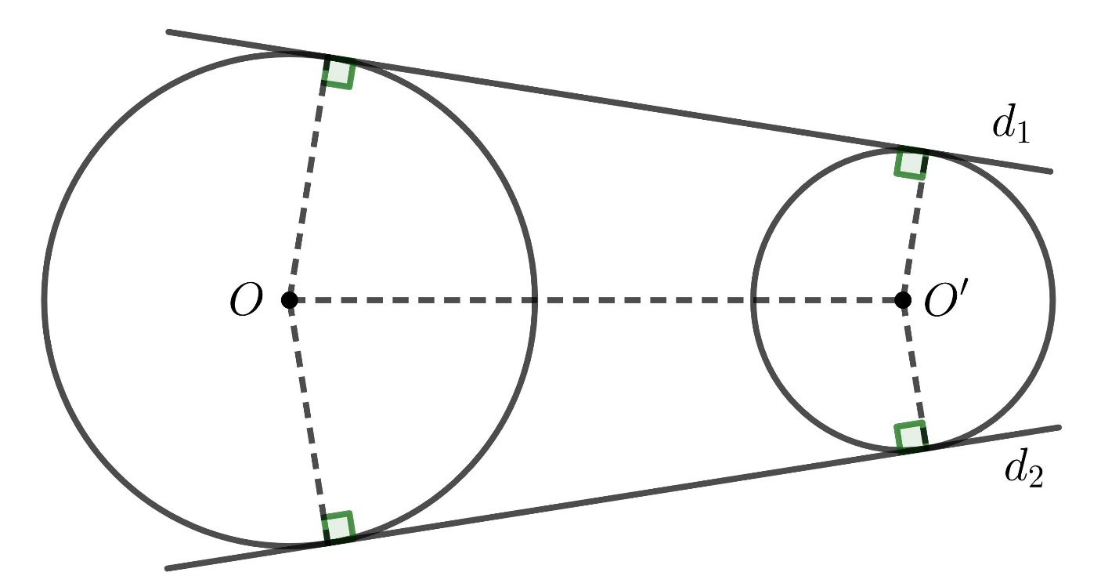
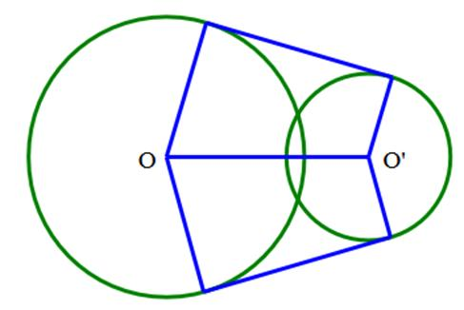
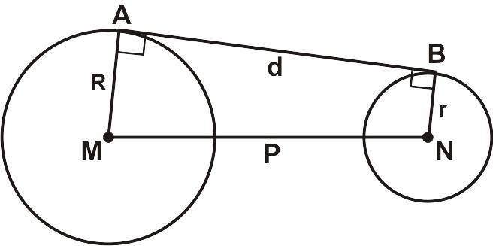
Therefore:
[
\boxed{\angle(\ell,O_1O_2)=90^\circ}
]

Coordinate Geometry
# Source: AI Source: Provided by: [Data Path: Persons Table -> ID Column: 1, Name_En Column: Motasem Essam] -> From: [ChatGPT] on [7/25/2026]
Suppose the centers are:
$$O_{1}=\left(x_{1},y_{1}\right)$$
and:
$$O_{2}=\left(x_{2},y_{2}\right)$$
The distance between their centers is:
$$d=\sqrt{{\left(x_{2}-x_{1}\right)}^{2}+{\left(y_{2}-y_{1}\right)}^{2}}$$
The circles are externally tangent when:
$$\boxed{\sqrt{{\left(x_{2}-x_{1}\right)}^{2}+{\left(y_{2}-y_{1}\right)}^{2}}=r_{1}+r_{2}}$$

Coordinate Example
# Source: AI Source: Provided by: [Data Path: Persons Table -> ID Column: 1, Name_En Column: Motasem Essam] -> From: [ChatGPT] on [7/25/2026]
Suppose:
$$O_{1}=\left(0,0\right) \\ O_{2}=\left(8,6\right)$$
and:
$$r_{1}=5 \\ r_{2}=5$$
Calculate the center distance:
$$d=\sqrt{{\left(8-0\right)}^{2}+{\left(6-0\right)}^{2}} \\ d=\sqrt{64+36} \\ d=\sqrt{100} \\ d=10$$
Now:
$$r_{1}+r_{2}=5+5=10$$
Therefore:
$$\boxed{d=r_{1}+r_{2}}$$
The circles are externally tangent.

Distance Between the Centers
# Source: AI Source: Provided by: [Data Path: Persons Table -> ID Column: 1, Name_En Column: Motasem Essam] -> From: [ChatGPT] on [7/25/2026]
The center-to-center distance is:
$$\boxed{d=r_{1}+r_{2}}$$
This is one of the most important formulas for externally tangent circles.

Position of the Tangency Point
# Source: AI Source: Provided by: [Data Path: Persons Table -> ID Column: 1, Name_En Column: Motasem Essam] -> From: [ChatGPT] on [7/25/2026]
Suppose the centers are $O_{1}$ and $O_{2}$.
The tangency point $P$ lies on the segment connecting the centers.
If:
$$O_{1}O_{2}=d$$
then:
$$O_{1}P=r_{1}$$
and:
$$PO_{2}=r_{2}$$
Therefore:
$$\boxed{O_{1}P+PO_{2}=O_{1}O_{2}}$$

External Tangency in Real Life
# Source: AI Source: Provided by: [Data Path: Persons Table -> ID Column: 1, Name_En Column: Motasem Essam] -> From: [ChatGPT] on [7/25/2026]
External tangency appears when two circular objects touch from the outside.
Examples include:
- Two wheels touching each other.
- Two gears in contact.
- Two circular rollers.
- Two balls touching.
- Two pipes touching externally.
- Two circular components in a machine.
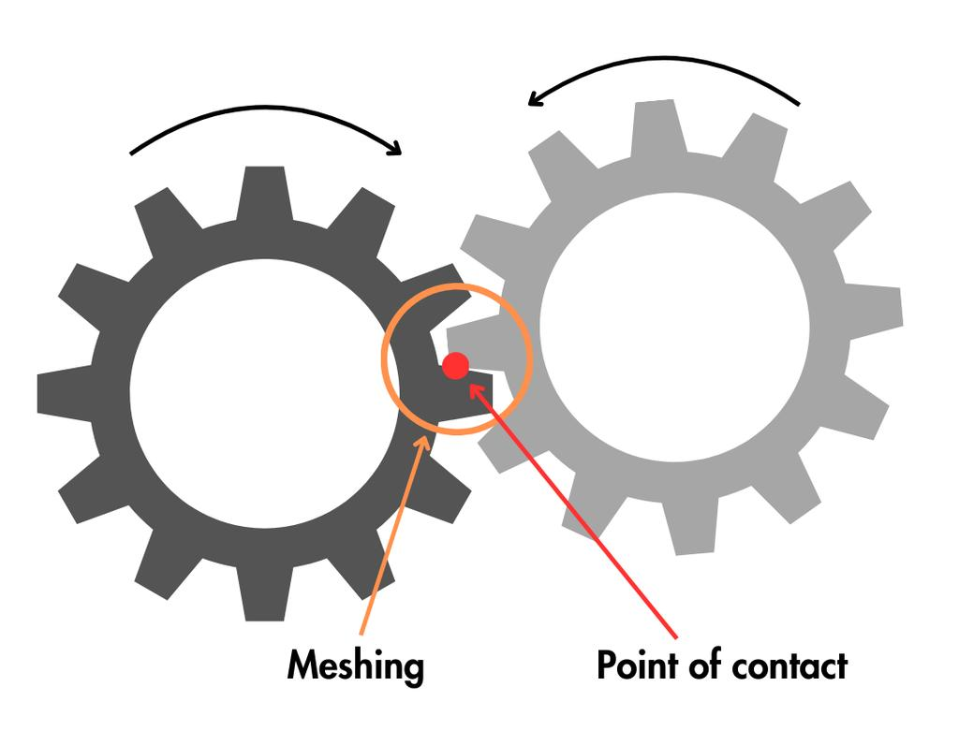
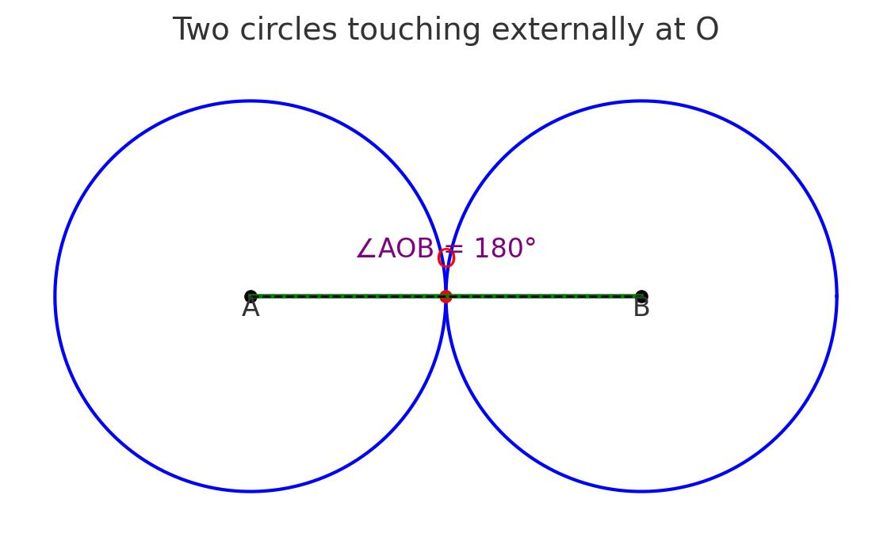
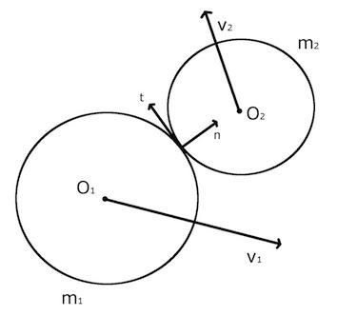
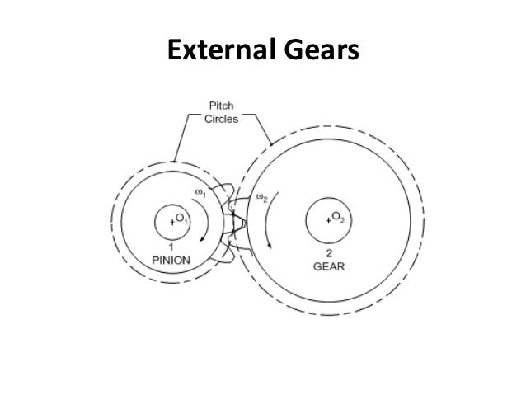
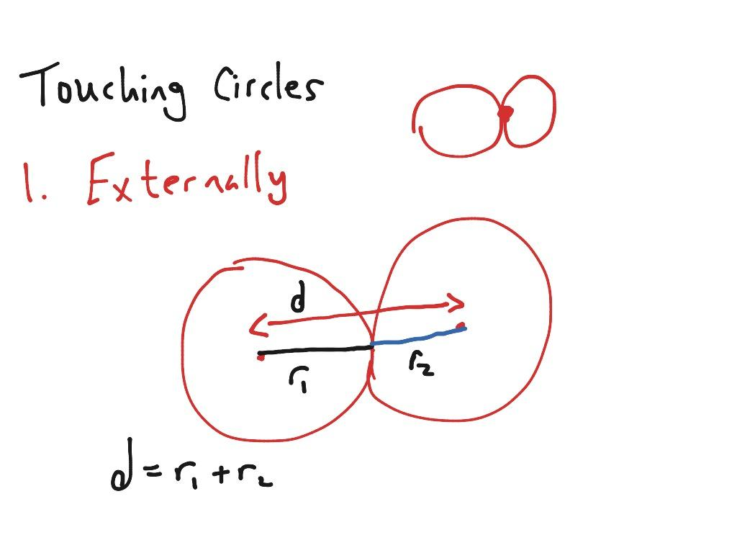
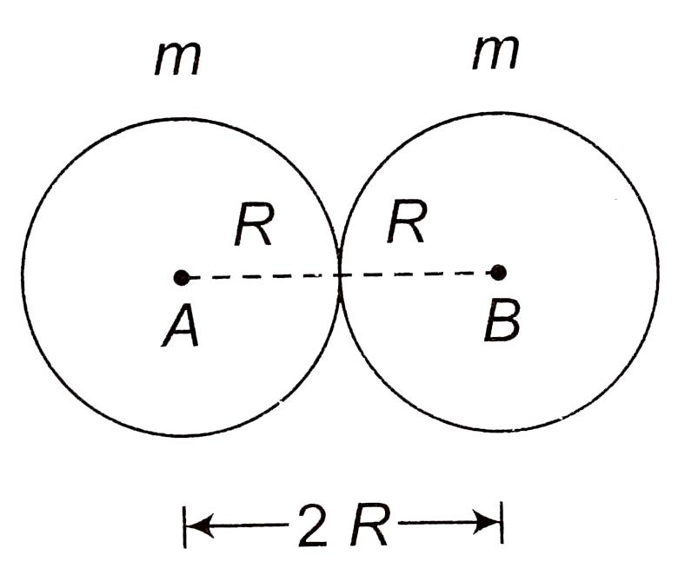

External Tangency in Gears
# Source: AI Source: Provided by: [Data Path: Persons Table -> ID Column: 1, Name_En Column: Motasem Essam] -> From: [ChatGPT] on [7/25/2026]
Two gears can be modeled using externally tangent circles representing their pitch circles.
If their pitch radii are:
$$r_{1}$$
and:
$$r_{2}$$
then their center distance is:
$$\boxed{d=r_{1}+r_{2}}$$
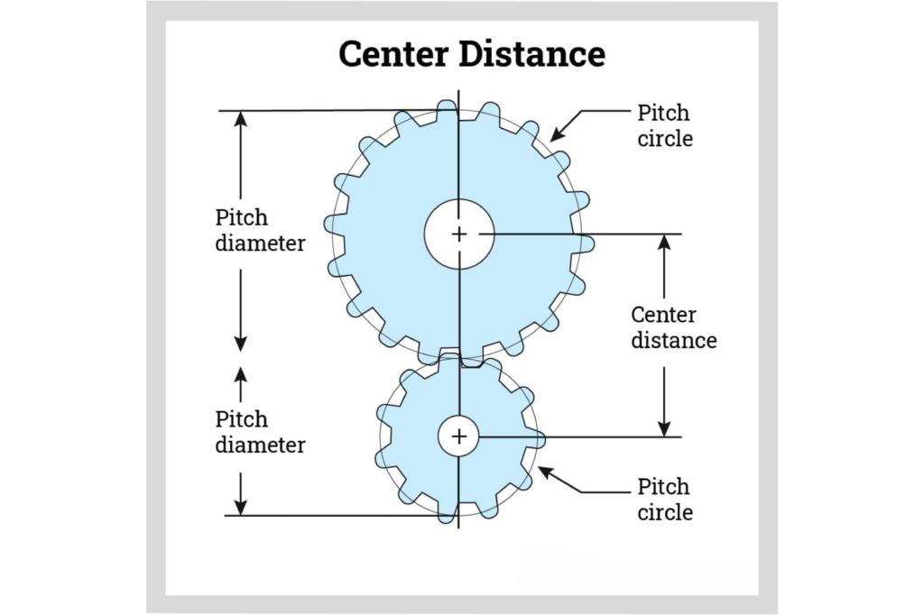
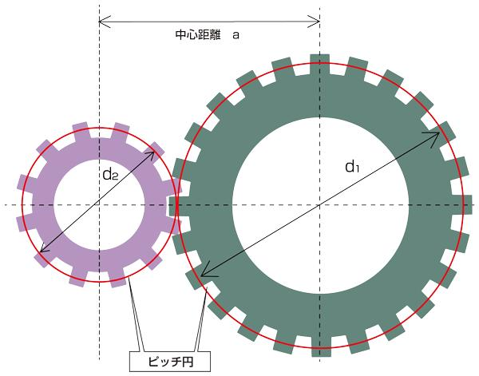
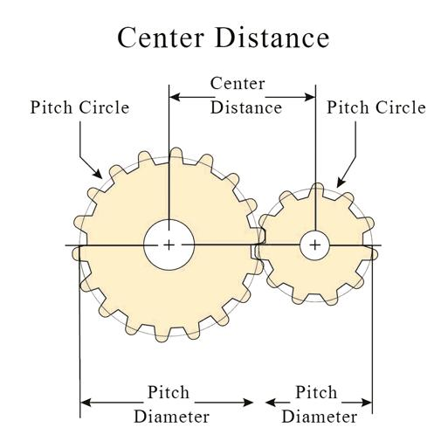
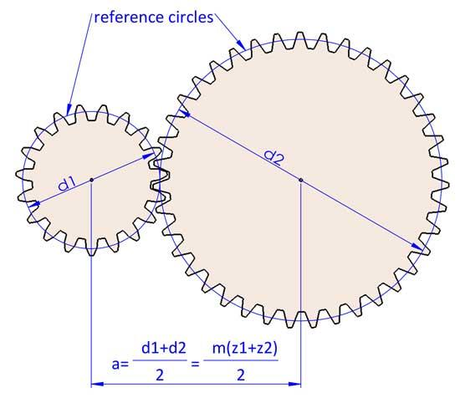
This relationship is important in mechanical design.

External Tangency in CAD
# Source: AI Source: Provided by: [Data Path: Persons Table -> ID Column: 1, Name_En Column: Motasem Essam] -> From: [ChatGPT] on [7/25/2026]
CAD systems use external tangency to create precise relationships between circular objects.
Applications include:
- Gears.
- Rollers.
- Wheels.
- Bearings.
- Mechanical components.
- Circular profiles.
- Smooth geometric constructions.
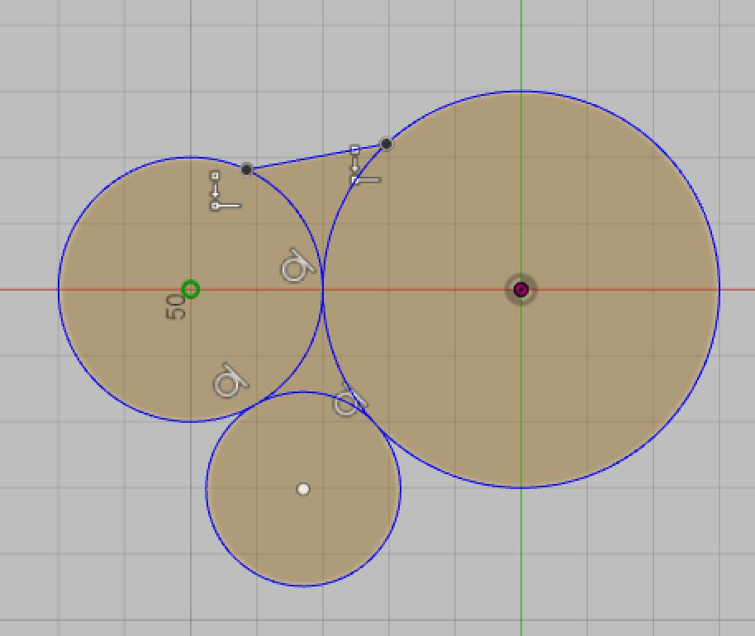
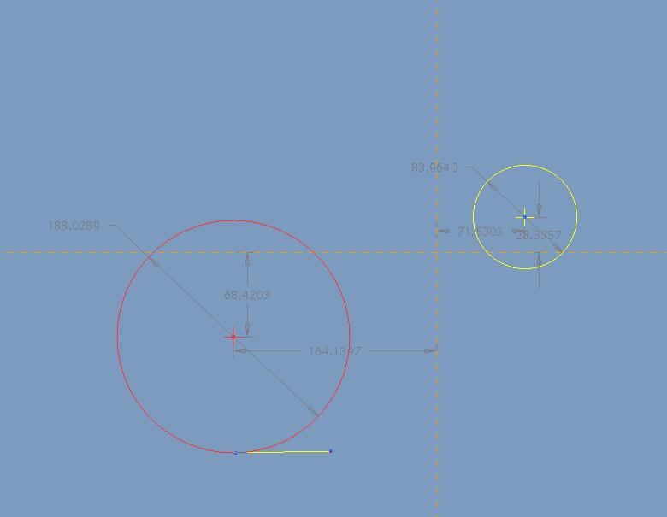
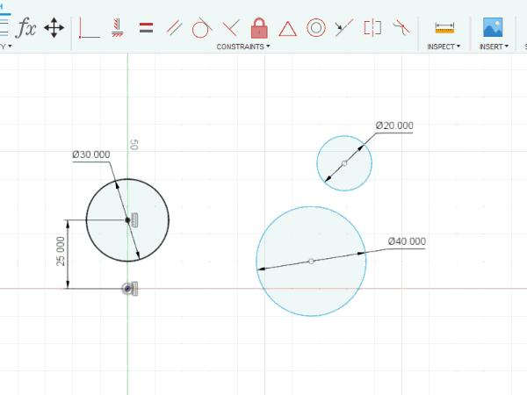

External Tangency in Geometry Construction
# Source: AI Source: Provided by: [Data Path: Persons Table -> ID Column: 1, Name_En Column: Motasem Essam] -> From: [ChatGPT] on [7/25/2026]
Given two circles, external tangency can be constructed by positioning their centers so that:
$$\boxed{O_{1}O_{2}=r_{1}+r_{2}}$$
Once this condition is satisfied, the circles touch at one point.

Advantages
# Source: AI Source: Provided by: [Data Path: Persons Table -> ID Column: 1, Name_En Column: Motasem Essam] -> From: [ChatGPT] on [7/25/2026]
Studying external tangency helps to:
- Understand relationships between circles.
- Calculate center distances.
- Solve circle geometry problems.
- Construct tangent circles.
- Analyze circular components.
- Design gears and wheels.
- Create CAD constraints.
- Understand mechanical contact.

Limitations
# Source: AI Source: Provided by: [Data Path: Persons Table -> ID Column: 1, Name_En Column: Motasem Essam] -> From: [ChatGPT] on [7/25/2026]
External tangency:
- Applies specifically to circles or other objects that touch externally.
- Requires exact geometric conditions.
- Can be difficult to verify when measurements are approximate.
- Must be distinguished from internal tangency.
- Must be distinguished from two-point intersection.

Comparison with Other Circle Relationships
# Source: AI Source: Provided by: [Data Path: Persons Table -> ID Column: 1, Name_En Column: Motasem Essam] -> From: [ChatGPT] on [7/25/2026]
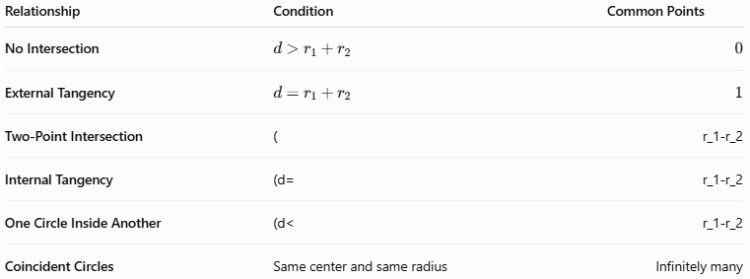
Relationship | Condition | Common Points
No Intersection | $$d>r_{1}+r_{2}$$ | $$0$$
External Tangency | $$d=r_{1}+r_{2}$$ | $$1$$
Two-Point Intersection | $$($$ | $$r_{1}-r_{2}$$
Internal Tangency | $$(d=$$ | $$r_{1}-r_{2}$$
One Circle Inside Another | $$(d<$$ | $$r_{1}-r_{2}$$
Coincident Circles | Same center and same radius | Infinitely many
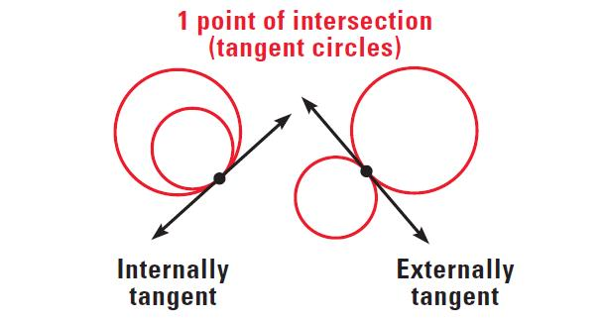
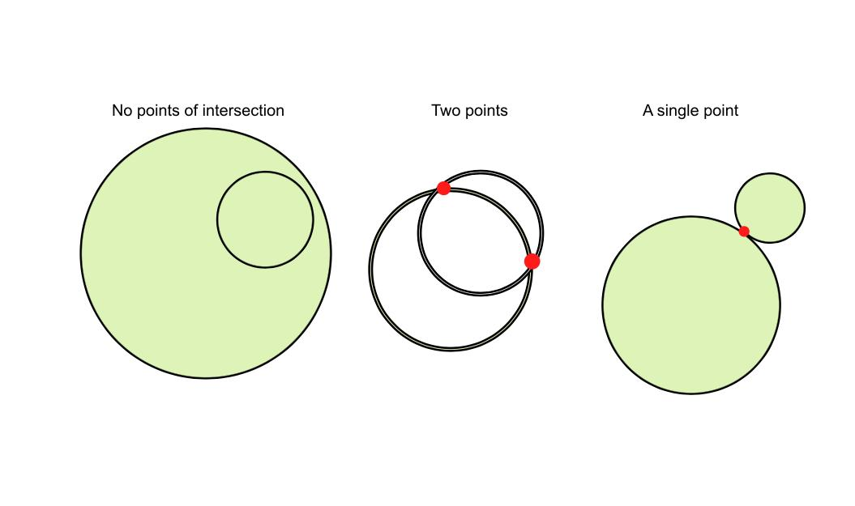

Key Points
# Source: AI Source: Provided by: [Data Path: Persons Table -> ID Column: 1, Name_En Column: Motasem Essam] -> From: [ChatGPT] on [7/25/2026]
- External Tangency occurs when two circles touch from the outside.
- They have exactly one common point.
- That point is called the point of tangency.
- The centers and point of tangency are collinear:
$$\boxed{O_{1}-P-O_{2}}$$
- The distance between centers is:
$$\boxed{d=r_{1}+r_{2}}$$
- The radii satisfy:
$$\boxed{O_{1}P=r_{1}} \\ \boxed{PO_{2}=r_{2}}$$
- The common tangent at the contact point is perpendicular to the line joining the centers:
$$\boxed{l⊥O_{1}O_{2}}$$

Conclusion
# Source: AI Source: Provided by: [Data Path: Persons Table -> ID Column: 1, Name_En Column: Motasem Essam] -> From: [ChatGPT] on [7/25/2026]
External Tangency is the relationship in which two circles touch each other externally at exactly one point. The point of contact is called the point of tangency, and the centers of the two circles and this point all lie on the same straight line. If the circles have radii $r_{1}$ and $r_{2}$, their centers must be separated by:
$$\boxed{d=r_{1}+r_{2}}$$
External tangency is fundamental to circle geometry, coordinate geometry, mechanical design, gears, wheels, CAD, engineering, and computer graphics.

